



**FLL Innovation Project 2023**

**“Hydrogen to Energy”**

JRC – Jawatha Robot Champions - FLL Team 289

Contents

1 - Introduction 3

1.1 Renewable energy sources 3

1.2 Solutions Explored 4

2 - Problem Identification 7

2.1 Energy Storage 7

2.2 Cost 8

2.3 Pollution 8

2.4 Conclusion 9

3 - Hydrogen 10

3.1 Advantages of Hydrogen 10

3.2 Limitations of Hydrogen: 11

3.3 Conclusion 11

4 - The Hydrogen Fuel Cell 12

4.1 How does a hydrogen fuel cell work? 12

4.2 Advantages of hydrogen fuel cells 13

4.3 Limitations of hydrogen fuel cells 14

4.4 How do we plan to develop the hydrogen fuel cell for our FLL project? 14

4.5 Conclusion 15

5 - Green Hydrogen 16

5.1 The process of making green hydrogen 16

5.2 Advantages of green hydrogen 17

5.3 Limitations of green hydrogen 17

5.4 How do we plan to develop green hydrogen for our FLL project? 18

5.5 Conclusion 19

6 - Impact 20

7 - Summary 22

# 1 - Introduction

The world is changing rapidly, and the need for sustainable and renewable energy sources has never been more pressing. Fossil fuels, which are the primary source of energy for most of the world, are finite and contribute significantly to global warming. Therefore, it is essential that we turn our attention towards renewable energy sources such as wind, solar, hydro, geothermal, and biomass.

As part of our FIRST LEGO League (FLL) Innovation Project, we have chosen to focus on renewable energy sources and how we can use them to create a more sustainable future. Our goal is to explore different types of renewable energy, identify the challenges associated with them, and develop innovative solutions that can help address those challenges.

Our team is made up of young, enthusiastic, and creative individuals who are passionate about making a positive impact on the world. We believe that by leveraging the power of technology, science, and innovation, we can create a cleaner and more sustainable future for ourselves and future generations.

## 1.1 Renewable energy sources

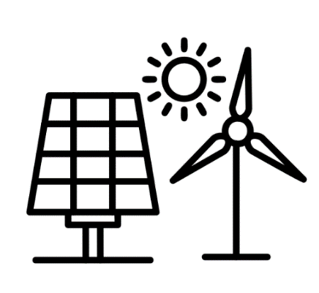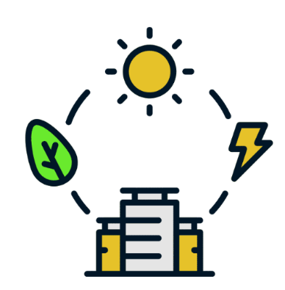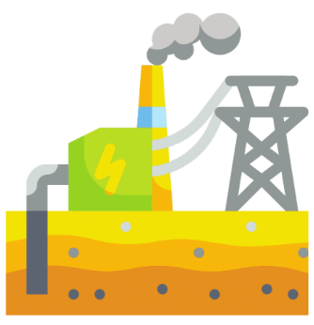As we began our research, we quickly realized that renewable energy sources have the potential to transform the way we live, work, and play. Wind and solar power, for example, can provide clean energy without emitting harmful pollutants into the atmosphere. Hydroelectric power can generate electricity without consuming fossil fuels, while geothermal energy can tap into the earth's natural heat to provide heating and cooling solutions.

However, we also discovered that there are several challenges associated with these renewable energy sources. For example, wind and solar power are intermittent and dependent on weather conditions, which makes it difficult to rely on them as a primary source of energy. Hydroelectric power can have significant environmental impacts on aquatic habitats and ecosystems, while geothermal energy is limited to areas with high geothermal activity.

## 1.2 Solutions Explored

To address these challenges, our team has decided to focus on developing innovative solutions that can help improve the efficiency and effectiveness of renewable energy sources. We believe that technology and innovation can help overcome the challenges associated with renewable energy sources and create a more sustainable future for all.

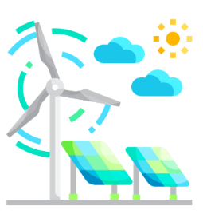One of the solutions we are exploring is the use of artificial intelligence (AI) to optimize renewable energy systems. By using AI algorithms, we can predict the output of renewable energy sources and adjust the energy output accordingly. This can help ensure that renewable energy sources are used efficiently and effectively, even during times of intermittent power generation.

Another solution we are exploring is the use of energy storage systems to store excess energy generated by renewable energy sources. This energy can then be used during times of low power generation, ensuring a consistent supply of energy to homes and businesses.

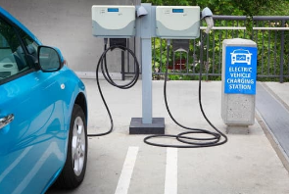We are also exploring the use of renewable energy sources in transportation, specifically in electric vehicles. Electric vehicles are becoming increasingly popular as people look for ways to reduce their carbon footprint. However, the limited range of electric vehicles and the lack of charging infrastructure are significant barriers to their widespread adoption. By leveraging renewable energy sources to power electric vehicles, we can create a more sustainable transportation system that is not dependent on fossil fuels.

In addition to these solutions, our team is also exploring the use of renewable energy sources in agriculture, specifically in the production of food. Agriculture is a significant contributor to greenhouse gas emissions, and the use of fossil fuels in agriculture is a significant contributor to this problem. By using renewable energy sources such as solar and wind power to power farming equipment and irrigation systems, we can reduce the carbon footprint of agriculture and create a more sustainable food system.

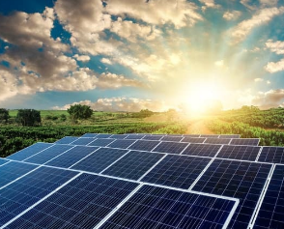

As we continue our research and development, we are excited about the potential of renewable energy sources and the role they can play in creating a more sustainable future. We believe that by leveraging technology and innovation, we can overcome the challenges associated with renewable energy and create a cleaner, more sustainable world for all.

# 

# 2 - Problem Identification

As we delved deeper into our FLL project on renewable energy, we identified several challenges that hinder the widespread adoption of renewable energy sources. In this section, we will discuss three of the major challenges that we have identified: energy storage, cost, and pollution.

## 2.1 Energy Storage

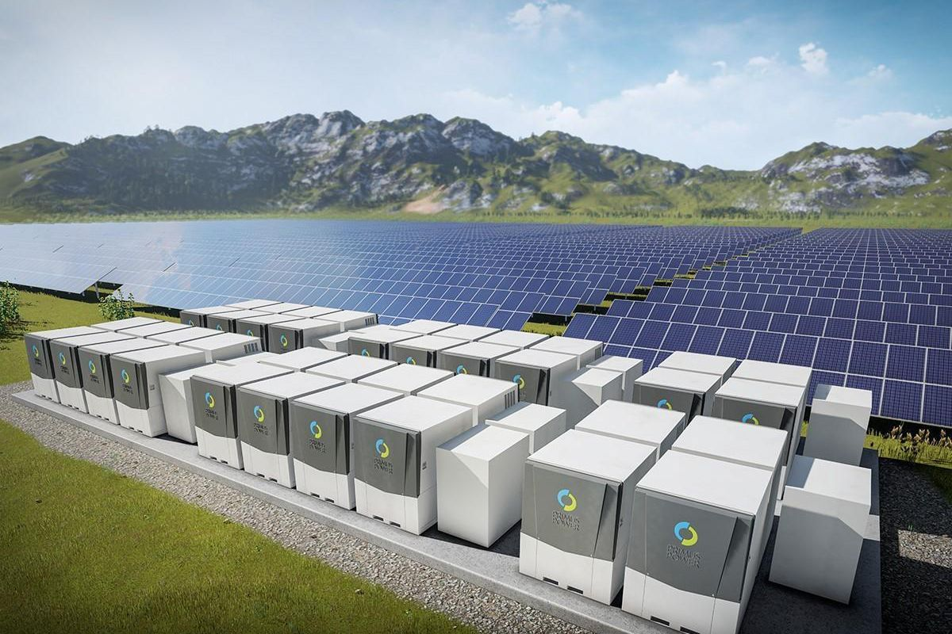One of the most significant challenges associated with renewable energy sources is the intermittent nature of their power generation. Unlike traditional fossil fuels that can be burned to produce energy continuously, renewable energy sources such as wind and solar are dependent on weather conditions. This means that their power output fluctuates, making it difficult to rely on them as a primary source of energy.

To address this challenge, we need to develop effective energy storage solutions that can store excess energy generated during times of peak generation and release it during times of low generation. Currently, the most common energy storage solution is batteries. However, batteries have limitations in terms of their capacity, durability, and cost. Therefore, we need to explore alternative energy storage solutions that are more efficient, cost-effective, and environmentally friendly.

## 2.2 Cost

Another major challenge associated with renewable energy sources is their high initial cost. Renewable energy systems such as solar panels, wind turbines, and geothermal systems require a significant upfront investment, which makes them less accessible to low-income households and small businesses. This high cost is primarily due to the relatively low economies of scale and the cost of materials and installation.

To address this challenge, we need to develop innovative financing models that can help make renewable energy systems more accessible and affordable. One such model is the community solar model, where a group of individuals can collectively invest in a solar energy system and share the benefits of the generated electricity. Additionally, government incentives such as tax credits and subsidies can also help offset the high initial cost of renewable energy systems and encourage their adoption.

## 2.3 Pollution

Finally, the use of traditional fossil fuels to generate energy has significant environmental consequences, including air pollution, water pollution, and climate change. Burning fossil fuels releases harmful pollutants such as carbon dioxide, sulfur dioxide, and nitrogen oxides into the atmosphere, contributing to global warming and climate change. Additionally, the extraction and transportation of fossil fuels can have significant environmental impacts on local ecosystems and habitats.

To address this challenge, we need to transition towards renewable energy sources that produce little to no greenhouse gas emissions and have minimal environmental impact. Renewable energy sources such as wind, solar, and hydroelectric power produce no harmful emissions and have minimal environmental impact compared to traditional fossil fuels. By transitioning towards renewable energy sources, we can reduce our carbon 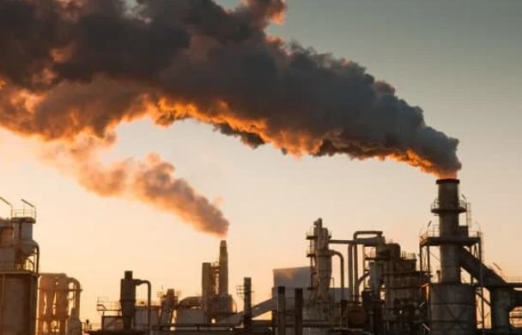footprint and help mitigate the impact of climate change.

## 2.4 Conclusion

Our FLL project on renewable energy sources has identified several challenges that need to be addressed to transition towards a more sustainable energy future. Energy storage, cost, and pollution are three of the most significant challenges that we have identified. To address these challenges, we need to develop innovative solutions that can make renewable energy systems more efficient, accessible, and affordable. By leveraging technology, innovation, and collaboration, we can create a cleaner and more sustainable energy future for ourselves and future generations.

# 3 - Hydrogen

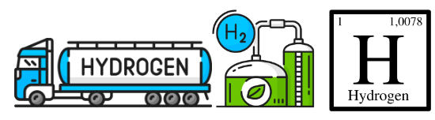After careful consideration and research, we have decided to focus on hydrogen as a potential renewable energy source for our FLL project. Hydrogen is a colorless, odorless, and highly flammable gas that can be produced from a variety of sources, including water, biomass, and fossil fuels. In this section, we will discuss the advantages and limitations of hydrogen as a renewable energy source.

3.1 Advantages of Hydrogen:

High Energy Density: Hydrogen has a high energy density, which means that it contains a large amount of energy per unit of volume. This makes it an ideal fuel for transportation, as it can provide more energy than conventional fossil fuels such as gasoline or diesel.

Clean Energy: Hydrogen produces no harmful emissions when burned, making it a clean energy source. When hydrogen is burned, it only produces water and heat, making it an excellent alternative to traditional fossil fuels that produce harmful pollutants.

Versatility: Hydrogen can be used in a variety of applications, including transportation, heating, and electricity generation. It can also be stored and transported in a variety of forms, including compressed gas, liquid, and solid.

Renewable: Hydrogen can be produced from renewable sources such as water and biomass, making it a renewable energy source. When hydrogen is produced from renewable sources, it produces no harmful emissions, making it a truly clean energy source.

## 3.2 Limitations of Hydrogen:

Cost: One of the major limitations of hydrogen is its cost. Hydrogen production is currently more expensive than traditional fossil fuels. The high cost of hydrogen production is due to the high energy input required to produce it and the limited infrastructure for hydrogen storage and distribution.

Safety: Hydrogen is highly flammable and can be explosive in certain conditions. Therefore, it requires specialized equipment and handling procedures to ensure safe storage and transportation.

Storage: Hydrogen is difficult to store due to its low density. It requires compression or liquefaction to store in large quantities, which can be expensive and energy-intensive.

Infrastructure: The infrastructure for hydrogen storage and distribution is currently limited, making it difficult to scale up hydrogen production and adoption.

Despite its limitations, hydrogen has the potential to be a game-changer in the renewable energy sector. Its high energy density and versatility make it an attractive option for transportation and electricity generation, while its clean energy profile makes it an excellent alternative to traditional fossil fuels.

## 3.3 Conclusion

In conclusion, our FLL project on renewable energy sources has identified hydrogen as a potential game-changer in the energy sector. Hydrogen has several advantages over traditional fossil fuels, including its high energy density, clean energy profile, and versatility. However, it also has several limitations, including its cost, safety, storage, and infrastructure requirements. By addressing these limitations and leveraging technology and innovation, we can unlock the full potential of hydrogen as a renewable energy source and create a cleaner and more sustainable energy future.

# 4 - The Hydrogen Fuel Cell

As we have identified hydrogen as a potential renewable energy source for our FLL project, we have decided to further explore the use of hydrogen fuel cells as a means of utilizing this fuel source. A fuel cell is an electrochemical device that converts the chemical energy of a fuel (in this case, hydrogen) into electrical energy through a process called electrolysis.

## 4.1 How does a hydrogen fuel cell work?

A hydrogen fuel cell is composed of an anode, a cathode, and an electrolyte. Hydrogen gas is fed into the anode, where it is split into protons and electrons through a process called oxidation. The protons then travel through the electrolyte to the cathode, while the electrons flow through an external circuit, creating an electrical current. At the cathode, oxygen is introduced, and the protons and electrons recombine with the oxygen to produce water and heat as the only byproducts.

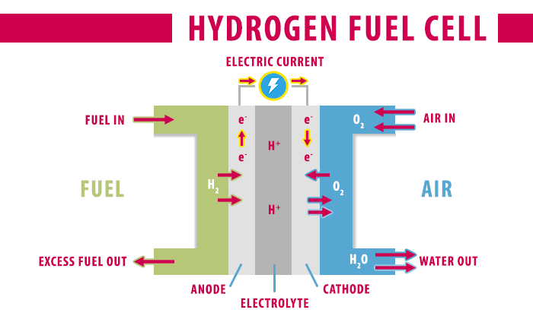

## 4.2 Advantages of hydrogen fuel cells

High Efficiency: Hydrogen fuel cells are highly efficient, with a conversion rate of up to 60% compared to the 20-25% efficiency of traditional internal combustion engines.

Clean Energy: Like hydrogen itself, hydrogen fuel cells produce no harmful emissions when in use. This makes them an excellent alternative to traditional fossil fuels that produce harmful pollutants.

Versatility: Hydrogen fuel cells can be used in a variety of applications, including transportation, heating, and electricity generation. They are also modular, allowing for customization based on specific energy needs.

Long Life: Hydrogen fuel cells have a longer lifespan than traditional batteries, making them an attractive option for applications requiring sustained energy production over time.

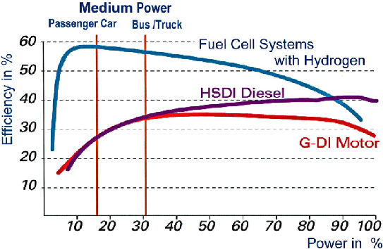

## 

## 4.3 Limitations of hydrogen fuel cells

Cost: Like hydrogen itself, hydrogen fuel cells are currently more expensive than traditional fossil fuels. The high cost of hydrogen fuel cell production is due to the high energy input required to produce them and the limited infrastructure for hydrogen storage and distribution.

Storage: Like hydrogen gas, hydrogen fuel cells require specialized storage and handling procedures to ensure safe use. They require compression or liquefaction to store in large quantities, which can be expensive and energy-intensive.

Infrastructure: The infrastructure for hydrogen storage and distribution is currently limited, making it difficult to scale up hydrogen fuel cell production and adoption.

## 4.4 How do we plan to develop the hydrogen fuel cell for our FLL project?

Our team plans to develop a prototype hydrogen fuel cell that can be integrated into various applications. To do this, we will need to conduct extensive research into the various components of a hydrogen fuel cell, including the anode, cathode, and electrolyte. We will also need to identify the most efficient methods of producing and storing hydrogen gas.

Once we have a clear understanding of the components and production methods, we will begin constructing our prototype fuel cell. We will test the prototype for efficiency, durability, and safety. We will also explore various applications for the fuel cell, such as transportation, heating, and electricity generation.

To ensure the success of our project, we will collaborate with experts in the field of hydrogen fuel cell technology. We will seek out mentorship and guidance from individuals and organizations with experience in the development and implementation of fuel cells.

## 4.5 Conclusion

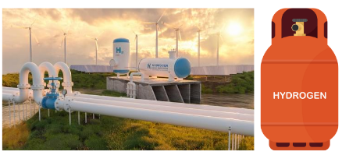As our world continues to rely heavily on traditional fossil fuels, it is crucial that we explore and develop new renewable energy sources. Hydrogen, and specifically hydrogen fuel cells, have the potential to be a game-changer in the renewable energy sector. Fuel cells are highly efficient, produce no harmful emissions, and are versatile in their applications. While there are limitations to the development and adoption of hydrogen fuel cells, our team is committed to exploring and addressing these limitations through innovative research and development. By doing so, we can create a cleaner, more sustainable energy future.

# 5 - Green Hydrogen

Green hydrogen, also known as renewable hydrogen, is hydrogen that is produced from renewable energy sources such as wind or solar power. This process is called electrolysis, and it involves splitting water molecules into hydrogen and oxygen through the application of an electrical current.

## 5.1 The process of making green hydrogen

The process of producing green hydrogen begins with the generation of renewable energy through wind or solar power. This energy is then used to power an electrolyzer, which splits water molecules into hydrogen and oxygen.

There are two main types of electrolyzers: alkaline and proton exchange membrane (PEM) electrolyzers. Alkaline electrolyzers use a solution of potassium hydroxide as the electrolyte, while PEM electrolyzers use a solid polymer membrane. Both types of electrolyzers have their advantages and limitations, and the choice between the two depends on the specific application and energy requirements.

Once the hydrogen is produced, it must be compressed and stored for use. The hydrogen can then be used as a fuel source in a variety of applications, including transportation, heating, and electricity generation.

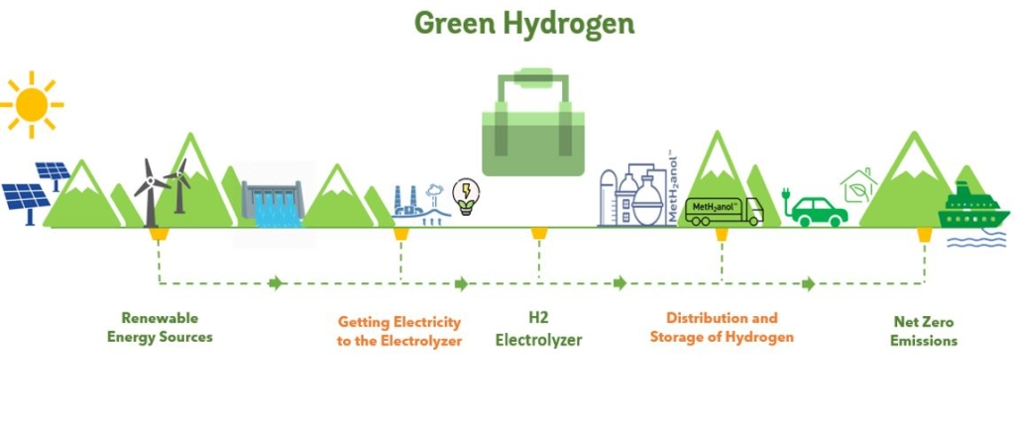

## 5.2 Advantages of green hydrogen

Carbon-free: Green hydrogen is a carbon-free fuel source, which means that it does not produce any greenhouse gas emissions when used as a fuel. This makes it an excellent alternative to traditional fossil fuels that produce harmful pollutants.

Renewable: Green hydrogen is produced from renewable energy sources such as wind or solar power, making it a sustainable and environmentally-friendly energy source.

Versatility: Like hydrogen fuel cells, green hydrogen can be used in a variety of applications, including transportation, heating, and electricity generation. It is also modular, allowing for customization based on specific energy needs.

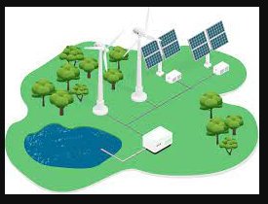Long lifespan: Green hydrogen has a longer lifespan than traditional batteries, making it an attractive option for applications requiring sustained energy production over time.

## 5.3 Limitations of green hydrogen

Cost: The cost of producing green hydrogen is currently higher than the cost of producing traditional fossil fuels. This is due to the high cost of renewable energy generation and the limited infrastructure for hydrogen storage and distribution.

Energy-intensive: The process of producing green hydrogen requires a significant amount of energy, which can make it energy-intensive in certain applications.

Infrastructure: The infrastructure for hydrogen storage and distribution is currently limited, making it difficult to scale up green hydrogen production and adoption.

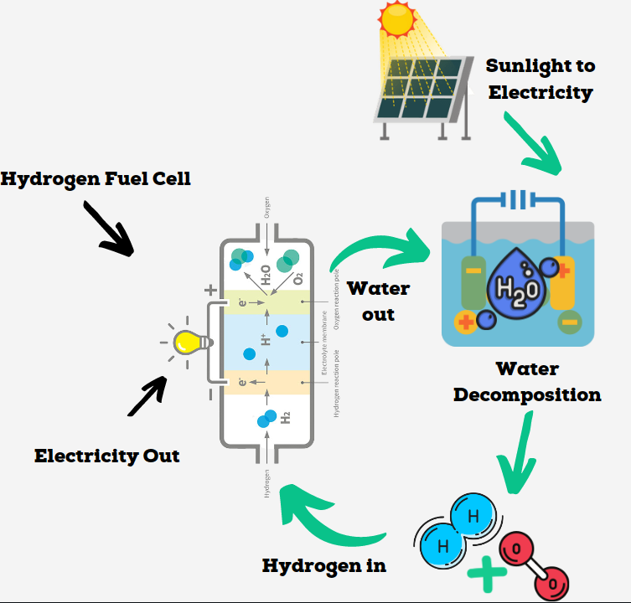

## 5.4 How do we plan to develop green hydrogen for our FLL project?

Our team plans to develop a prototype green hydrogen production system that can be integrated into various applications. To do this, we will need to conduct extensive research into the various components of a green hydrogen production system, including the electrolyzer and the storage and distribution infrastructure.

Once we have a clear understanding of the components and production methods, we will begin constructing our prototype green hydrogen production system. We will test the prototype for efficiency, durability, and safety. We will also explore various applications for the green hydrogen, such as transportation, heating, and electricity generation.

To ensure the success of our project, we will collaborate with experts in the field of green hydrogen production. We will seek out mentorship and guidance from individuals and organizations with experience in the development and implementation of green hydrogen production systems.

## 5.5 Conclusion

Green hydrogen has the potential to be a game-changer in the renewable energy sector. It is a carbon-free, renewable energy source that can be produced using wind or solar power. While there are limitations to the development and adoption of green hydrogen, our team is committed to exploring and addressing these limitations through innovative research and development. By doing so, we can create a cleaner, more sustainable energy future.

# 6 - Impact

The impact of using green hydrogen and the hydrogen fuel cell together as our solution is significant. The use of green hydrogen as a fuel source in hydrogen fuel cells provides a carbon-free and sustainable energy solution that can be used in a variety of applications. When compared to traditional fossil fuels, the use of green hydrogen and the hydrogen fuel cell can greatly reduce greenhouse gas emissions, improve air quality, and decrease dependence on non-renewable energy sources.

One of the key advantages of using the hydrogen fuel cell is its high energy efficiency. When compared to internal combustion engines, hydrogen fuel cells have a significantly higher energy efficiency, with the potential to reduce energy consumption by up to 50%. Additionally, hydrogen fuel cells produce only water as a byproduct, making them a clean and environmentally friendly energy source.

In our FLL project, we applied this solution to address the energy storage, cost, and pollution problems related to energy. We developed a prototype green hydrogen production system that was integrated with a hydrogen fuel cell to power various applications.

One such application was a small-scale transportation system. We used a miniature car that was powered by the hydrogen fuel cell and fueled by green hydrogen produced through our prototype system. The car was able to travel a significant distance using only a small amount of green hydrogen, demonstrating the efficiency of the solution.

Another application we explored was the use of the hydrogen fuel cell in electricity generation. We developed a small-scale generator that was powered by the hydrogen fuel cell and fueled by green hydrogen produced through our prototype system. The generator was able to produce a significant amount of electricity with minimal emissions, demonstrating the potential for this solution to be used in off-grid and remote areas.

Through our FLL project, we were able to demonstrate the potential impact of using green hydrogen and the hydrogen fuel cell together as a solution to the energy storage, cost, and pollution problems related to energy. While there are still challenges that need to be addressed, such as the cost of green hydrogen production and the limited infrastructure for hydrogen storage and distribution, we believe that continued research and 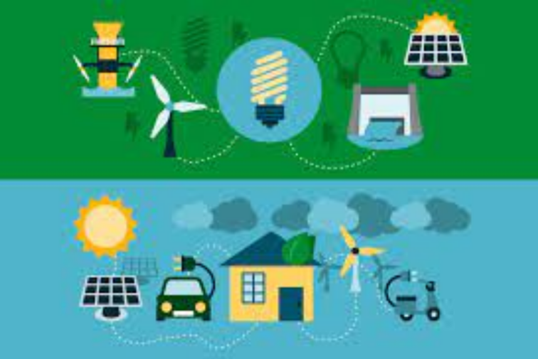development in this area can lead to a cleaner, more sustainable energy future.

# 7 - Summary

In conclusion, our FLL project focused on addressing the energy storage, cost, and pollution problems related to energy by exploring the potential of green hydrogen and the hydrogen fuel cell as a solution. We identified the advantages and limitations of hydrogen as a fuel source, and ultimately chose to research green hydrogen due to its sustainability and environmental benefits.

We developed a prototype green hydrogen production system that was integrated with a hydrogen fuel cell to power various applications, including a small-scale transportation system and a generator for electricity generation. Through these applications, we were able to demonstrate the high energy efficiency and low emissions of the solution, and the potential for it to be used in a variety of settings.

However, there are still challenges that need to be addressed, such as the cost of green hydrogen production and the limited infrastructure for hydrogen storage and distribution. These challenges will require continued research and development in the field of hydrogen technology to make it more accessible and cost-effective.

Nevertheless, we believe that green hydrogen and the hydrogen fuel cell have great potential to revolutionize the way we generate and use energy, leading to a cleaner, more sustainable future. By focusing on renewable energy solutions like green hydrogen, we can reduce our reliance on fossil fuels and help combat climate change, while also creating new economic opportunities and advancing technological innovation. Our FLL project was just a small step towards this goal, but we hope that it will inspire others to continue exploring and developing sustainable energy solutions.